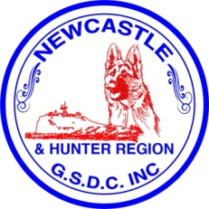
Newcastle & Hunter Region German Shepherd Dog Club Inc.
Nomination Form 2020/2021
Election of Office Bearer of the Association or Members of the Committee.
I hereby nominate..............................................................for the position
Of............................................ of the above Association for 2020/2021 Year
Nominated by.........................................................
Signed.....................................................................
I hereby Accept nomination for the above Position

Signed........................................................................... date...................................
This nomination shall be delivered to The Secretary no later than 6th September 2020 being the date 21 days before the date of the Annual General Meeting to be held on the 27th September 2020 where the Ballot for the election will take place (if required).
Positions to be elected are
President, Vice President, Secretary, Treasurer, 5 Committee members. Also to be elected and can be from the 5 Committee members, Chief Instructor Obedience, Breed Services, Membership Registrar, Public Officer.
Other non committee positions which we fill from within the Club/Committee are
Assistant Chief Instructor, Pointscore Co-Ordinator, Trial Secretary, Website Co-Ordinator, Social Media Co-Ordinator, Canteen Manager, Social Secretary.

